ADVANCED SEMINAR PLAN (Hauptseminar)
< REAL TIME & EMBEDDED SYSTEMS FOR AUTOMOTIVE > < ILMENAU UNIVERSITY OF TECHNOLOGY> <DISTRIBUTED SYSTEMS & OPERATING SYSTEMS GROUP >
Document Revision #: 1.0 Student Name : Diwakar Bajaj Course Name: MSc. Research in Computer & Systems Engineering Year : 2014 (Summer Semester) Advisor: Dr.-Ing. Hans-Albrecht Schindler

Real Time Systems play a very significant role in several computer systems especially in Embedded Systems. Real Time operating systems are important part of these real time systems in which we hav

- Introduction
An Automotive Embedded System is a computer system that is embedded into a car to control its software functionality. An embedded computer unit is called ECU (Electronic Control Unit). In automotive electronics, ECU is standard term for any embedded system which controls one or more electrical system or subsystems in a vehicle. There are different types of ECU’s which can be used in the car’s computer. In this paper, we will talk about Automotive Embedded Systems, Real Time Operating Systems for Automotive, Electronic Control Unit, AUTOSAR (Automotive Open System Architecture), JasPar (Japan Automotive Software Platform Architecture) and ASIL (Automotive Safety Integrity Level). Moreover, we will also introduce future trends of Automotive Embedded Systems and overview of Next-Generation RTOS for Automotive Systems.
Example:
Lexus LS-460
- It contains more than 100 ECUs which are embedded when optional equipment is installed
- About 7,000,000 lines of software embedded
- Released in September, 2006

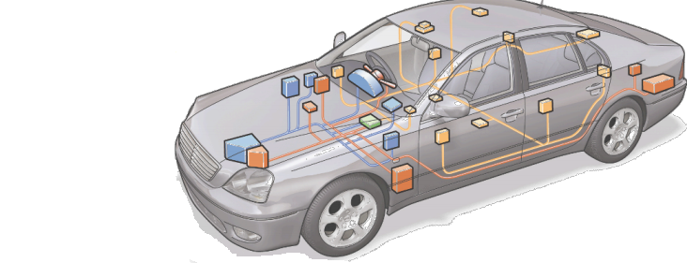

Fig. 1 Lexus LS-460 [1]

- Topics Covered
In this paper, we will discover about different topics which can be helpful in Automotive Embedded Systems. However, we will start from the overview of RTOS (Real Time Operating System) and RTS (Real Time Scheduling). Further, we will talk about Real Time & Embedded Systems for Automotive. In this part, we will discuss about RTOS for Automotive, Electronic Control Unit, General features for Automotive Embedded Systems, Classification of Automotive Embedded Systems, Specific Functional and Non-Functional Requirements for Automotive Embedded Systems, Evaluation steps, different problems of Automotive Embedded Systems, AUTOSAR (Automotive Open System Architecture), JasPar (Japan Automotive Software Platform Architecture), and ASIL (Automotive Safety Integrity Level). Moreover, in future work we will talk about next generation RTOS for Automotive Systems.

- Milestones
The following table represents seminar milestones with estimated completion dates and time requirements: -

Sr. No | Milestone | Completion Date (Calendar Weeks) | Time in Weeks | Results
1.1 | Real Time Operating Systems | Week 14 (March 31, 2014 to April 7, 2014) | 1 | Document
1.2 | Real Time Scheduling | Week 15 (April 7, 2014 to April 13, 2014) | 1 | Document
2.1 | Real Time and Embedded Systems for Automotive (RTOS for Automotive) | Week 16 (April 14, 2014 to April 20, 2014) | 1 | Document
2.2 | Electronic Control Unit | Week 17 (April 21, 2014 to April 27, 2014) | 1 | Document
2.3 | General Features of Automotive Embedded Systems | Week 18 (April 28, 2014 to May 4, 2014) | 1 | Document
2.4 | Classification of Automotive Embedded Systems | Week 19 (May 5, 2014 to May 11, 2014) | 1 | Document
2.5 | Specific Functional and Non-Functional Requirements | Week 20 (May 12, 2014 to May 18, 2014) | 1 | Document
2.6 | Evaluation Steps | Week 21 (May 19, 2014 to May 25, 2014) | 1 | Document
2.7 | Different Problems for Automotive Embedded Systems | Week 22 (May 26, 2014 to June 1, 2014) | 1 | Document
3.1 | AUTOSAR (Introduction) | Week 23 (June 2, 2014 to June 8, 2014) | 1 | Document
3.2 | Structure of AUTOSAR Software Platform | Week 24 (June 9, 2014 to June 15, 2014) | 1 | Document
3.3 | Features of AUTOSAR for RTOS Development | Week 25 and Week 26 ( June 16, 2014 to June 29, 2014) | 2 | Document
4.1 | JasPar (Introduction) | Week 27 (June 30, 2014 to July 6, 2014) | 1 | Document
4.2 | Difference between AUTOSAR and JasPar | Week 28 (July 7, 2014 to July 13, 2014) | 1 | Document
5.1 | ASIL (Introduction) | Week 29 (July 14, 2014 to July 20, 2014) | 1 | Document
5.2 | Classification of ASIL | Week 30 (July 21, 2014 to July 27, 2014) | 1 | Document
6 | Conclusion and Future Work | Week 31 (July 28, 2014 to Aug 3, 2014) | 1 | Document
 | 1st Review | Week 32 (Aug 4, 2014 to Aug 10, 2014) | 1 | Document-Resubmission
 | 2nd Review | Week 33 (Aug 11, 2014 to Aug 17, 2014) | 1 | Document-Resubmission
 | 3rd Review (If necessary) | Week 34 (Aug 18, 2014 to Aug 24, 2014) | 1 | Document-Resubmission
 | Final Submission | Week 34 or Week 35 (Aug 25, 2014 to Aug 31, 2014) | 1 | Final Document Submission

